TC_001_Login & Logout

Validate logging in to the application using valid phone number and valid OTP

Launch he browser > Enter the URL and credentials > Click the login link > Enter user valid phone number > Click the next button > OTP will receive to register phone number > Enter OTP and click verify button

Login Successfully

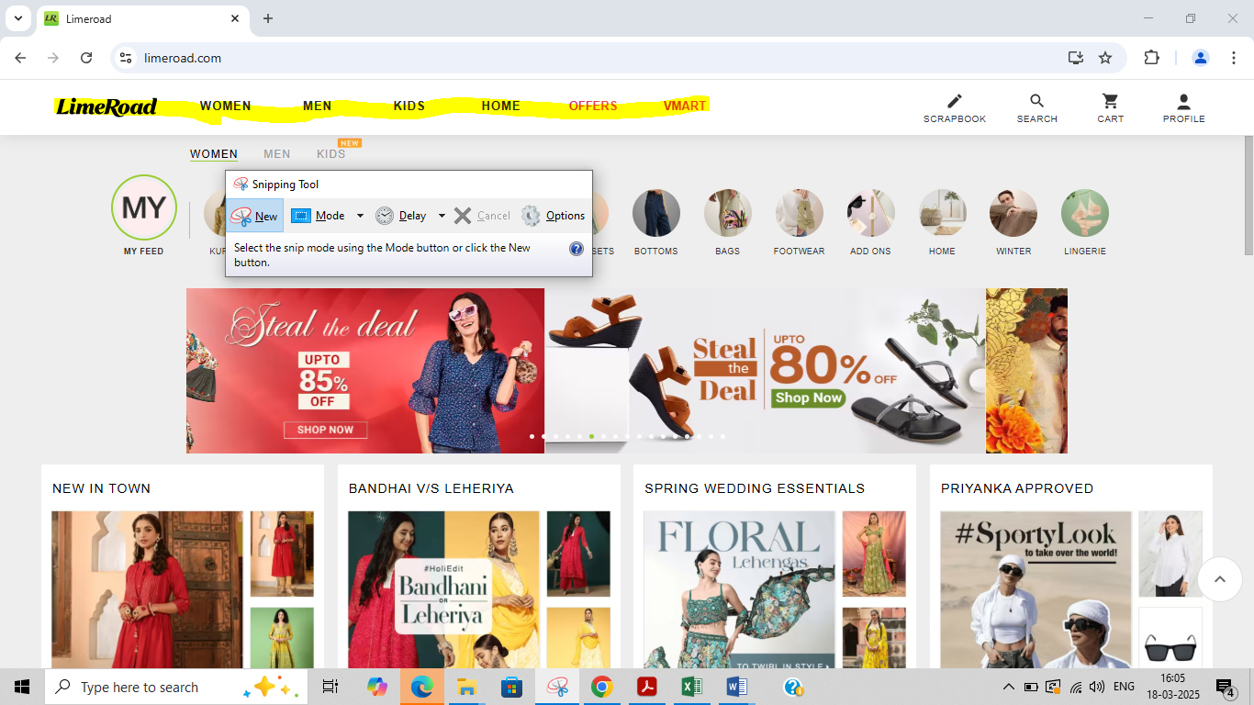

TC_001_Login & Logout

Validate logging in to the application using invalid phone number

Launch he browser > Enter the URL and credentials > Click the login button > Enter user invalid phone number > Click the next button

System displayed A pop message to show an error "10 digit valid phone number required"

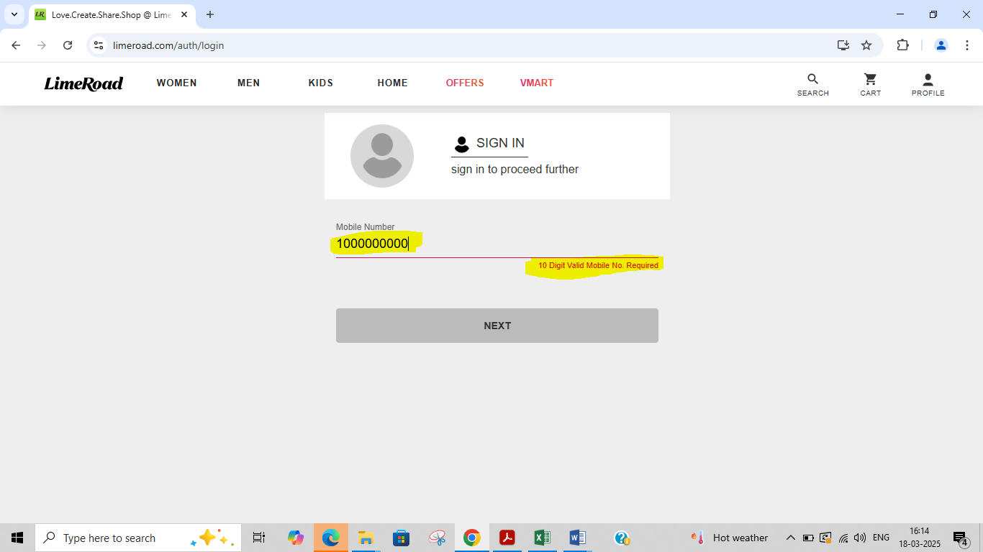

TC_003_Login & Logout

Validate logging in to the application using incorrect phone number

Launch he browser > Enter the URL and credentials > Click the login button > Enter user invalid phone number > Click the next button

System displayed A pop message to show an error "10 digit valid phone number required"

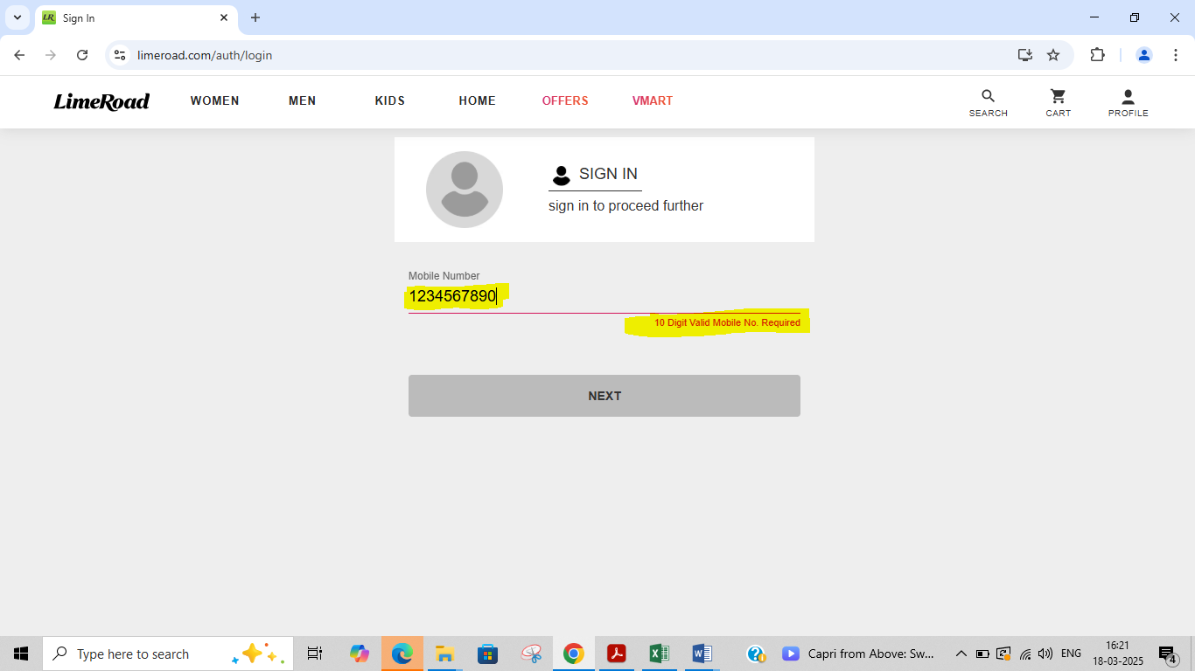

TC_004_Login & Logout

Validate logging in to the application without providing any credentials in phone number field

Launch he browser > Enter the URL and credentials > Click the login button > Don't enter anything in the phone number field

System displayed 1.Next button is not working without numbers

2.A pop message to show an error "Valid phone number required"

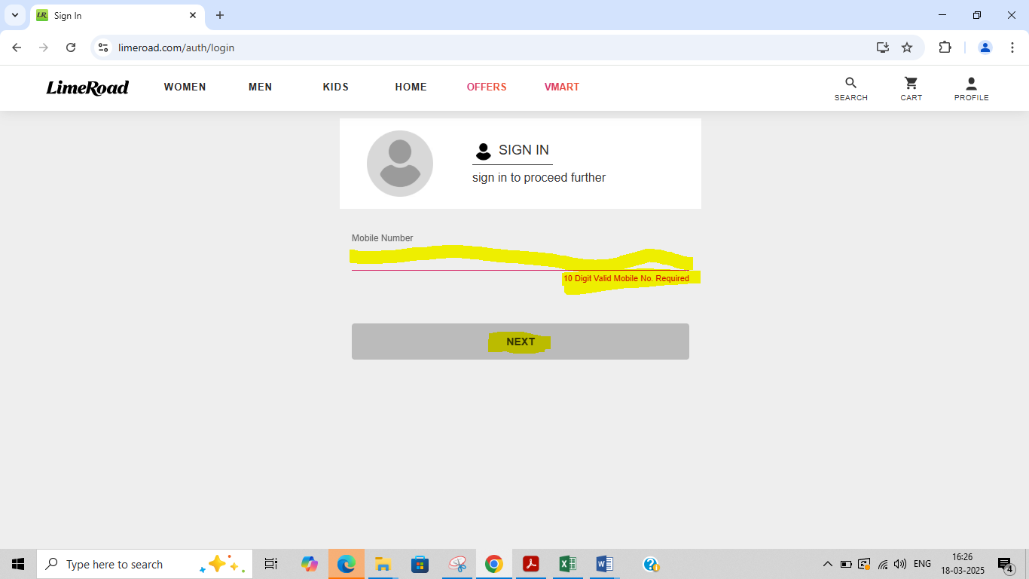

TC_005_Login & Logout

Validate logging in to the application using valid phone number and invalid OTP

Launch he browser > Enter the URL and credentials > Click the login button > Enter user valid phone number > Click the next button > OTP will receive to register phone number > Enter invalid OTP and click verify button

System displayed 1.OTP page will automatically refersh

2.Verify button is not working with greater or less than 4 digit numbers

3..A pop message to show an error "Please enter correct OTP"

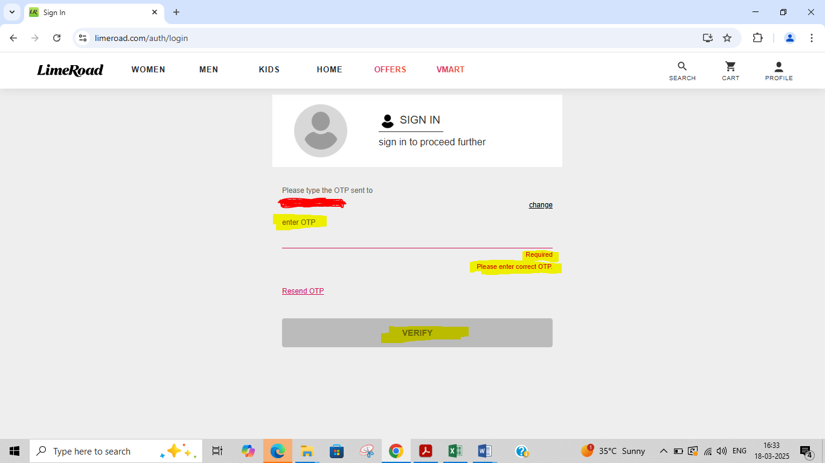

TC_006_Login & Logout

Validate logging in to the application using valid phone number and incorrect OTP

Launch he browser > Enter the URL and credentials > Click the login button > Enter user valid phone number > Click the next button > OTP will receive to register phone number > Enter incorrect OTP and click verify button

System displayed 1.OTP page will automatically refresh

2..A pop message to show an error "Please enter correct OTP"



TC_007_Login & Logout

Validate logging in to the application using valid phone number and without providing any credentials in OTP field

Launch he browser > Enter the URL and credentials > Click the login button > Enter user valid phone number > Click the next button > OTP will receive to register phone number > Don't enter anything in OTP field

System displayed 1.Verify button is not working without numbers

2.A pop message to show an error " enter OTP"

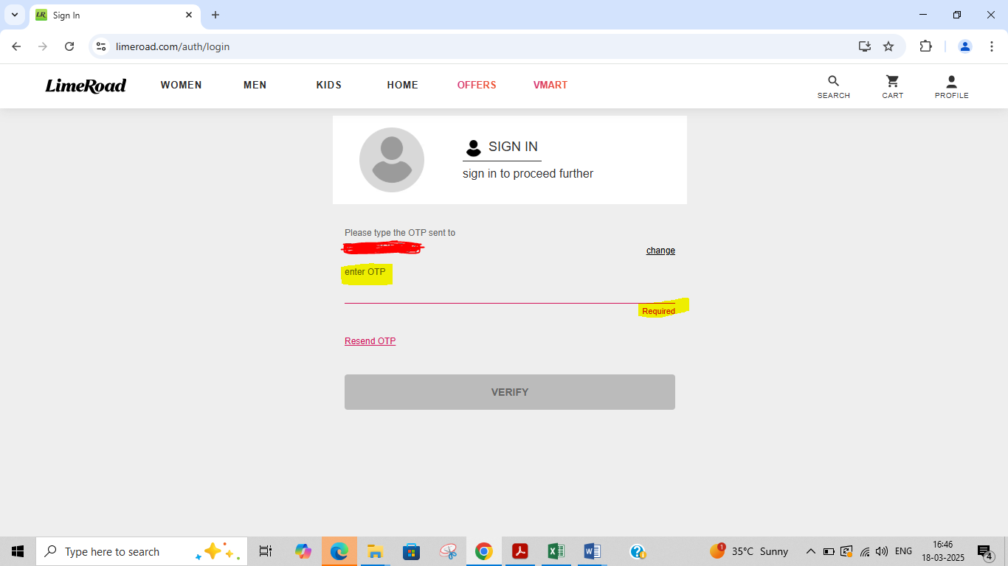

TC_008_Login & Logout

Validate the number of unsucessful login attempts

Launch he browser > Enter the URL and credentials > Click the login button > Enter user valid phone number > Click the next button > OTP will receive to register phone number > Enter incorrect OTP and click verify button > Repeat the last step for 4 more times

System displayed 1.OTP page will automatically refersh

2.A pop message to show an error "You have exceed the number of failed attempts please try again after sometime"

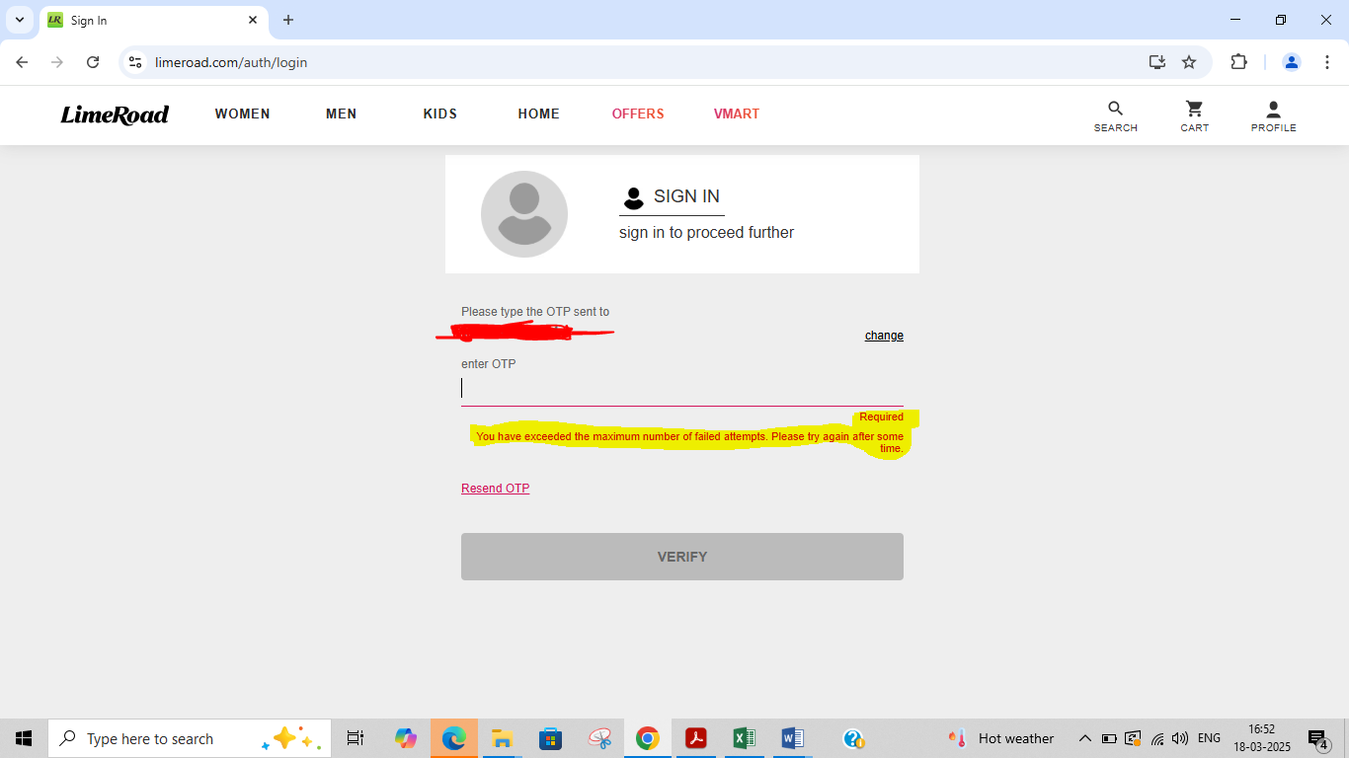

TC_009_Login & Logout

Validate logging in to the application using valid phone number and Resend OTP option within 5 mins of last attempts

Launch he browser > Enter the URL and credentials > Click the login button > Enter user valid phone number > Click the next button > OTP will receive to register phone number > Enter Resend OTP button

System displayed A pop message to show an error "attempts exhausted retry after 30 mins"

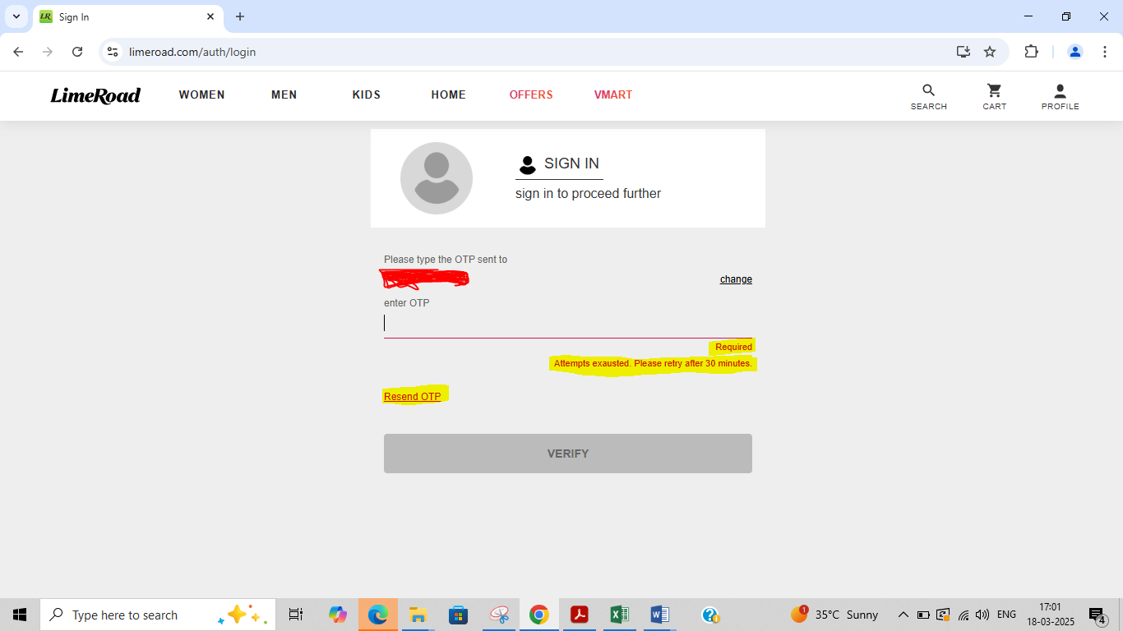

TC_010_Login & Logout

Validate logging in to the application using valid phone number and expire OTP option

Launch he browser > Enter the URL and credentials > Click the login button > Enter user valid phone number > Click the next button > OTP will receive to register phone number > Enter the OTP after 30 min > click verify button

System displayed Successful login

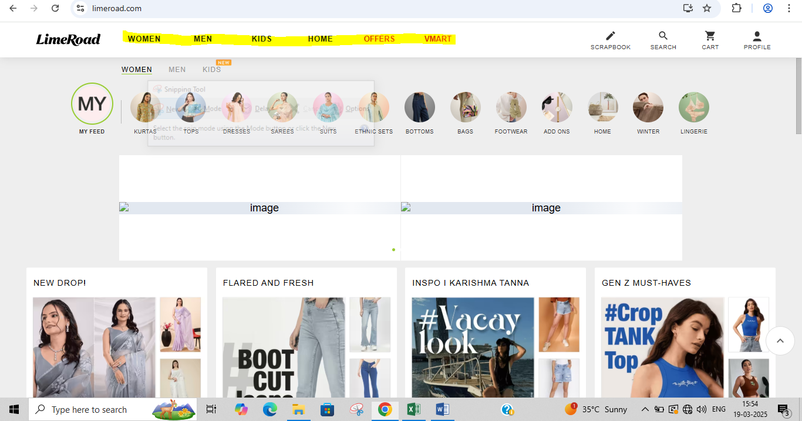

TC_011_Login & Logout

Validate logging in to the application using change phone number

Launch he browser > Enter the URL and credentials > Click the login button > Enter user valid phone number > Click the next button > OTP will receive to register phone number > Click the change button > Enter the another phone number > OTP will receive to another phone number > Enter the OTP & Click the verify button

System displayed Sucessful login

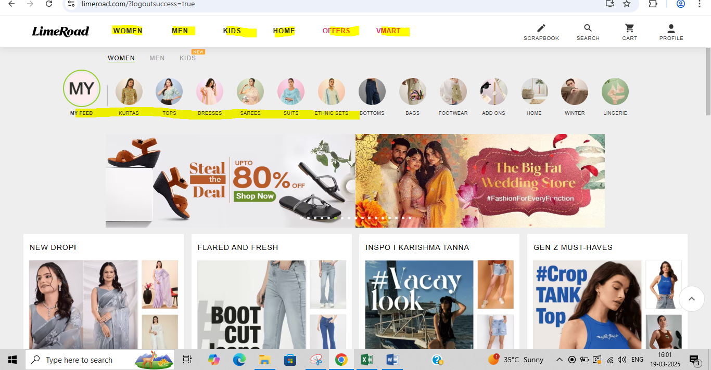

TC_012_Login & Logout

Validate logging in to the application using Keyboard key (Enter)

Launch the browser > Enter the URL and credentials > Click the login button > Enter user valid phone number > Click the 'Enter' button in keyboard > OTP will receive to register phone number > Enter the OTP & Click the' Enter' button in keyboard

System displayed Successful login

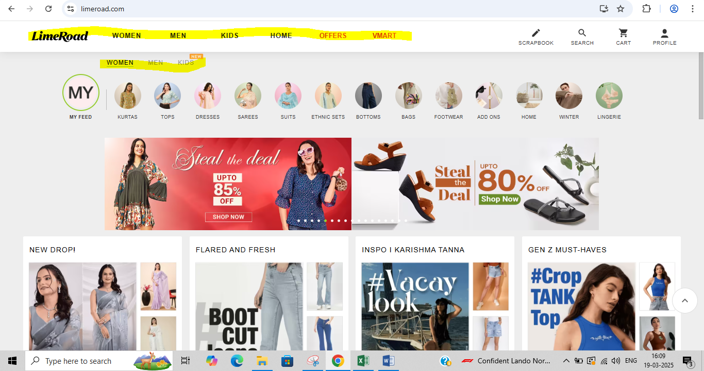

TC_013_Login & Logout

Validate phone number and OTP text fields in the login page have the place holder text

Launch the browser > Enter the URL and credentials > Click the login button > Enter user valid phone number

Proper place holder text displayed above the phone number and OTP fields



TC_014_Login & Logout

Validate logging into the application and browsing back using browser back button

Launch he browser > Enter the URL and credentials > Click the login button > Enter user valid phone number > Click the next button > OTP will receive to register phone number > Enter OTP and click verify button > Click on browser back button

System displayed User not logged out



TC_015_Login & Logout

Validate the copying of the text entered in to phone number field

Launch he browser > Enter the URL and credentials > Click the login button > Enter phone number in the field > Select the number entered in to the phone number field and right click to select copy option > Select the text entered into the phone number field & press(Ctrl+C) shortcut for copying

Number copied

Number pasteted

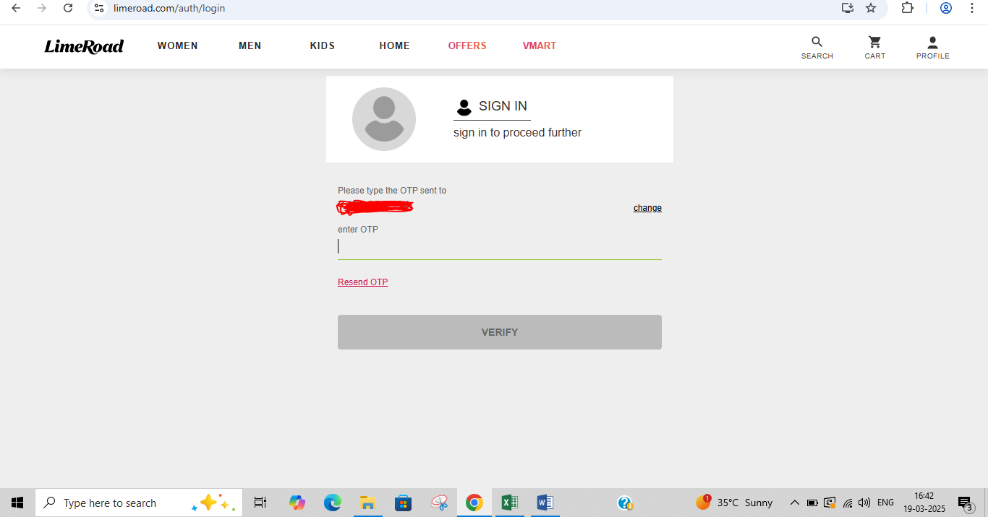

TC_016_Login & Logout

Validate logging into the application, closing the browser without logging out & opening the application in the browser again

Launch he browser > Enter the URL and credentials > Click the login button > Enter user valid phone number > Click the next button > OTP will receive to register phone number > Enter OTP and click verify button > Close the browser > Open the browser and open thr application URL

Logged in session is still maintained & user is not logged out

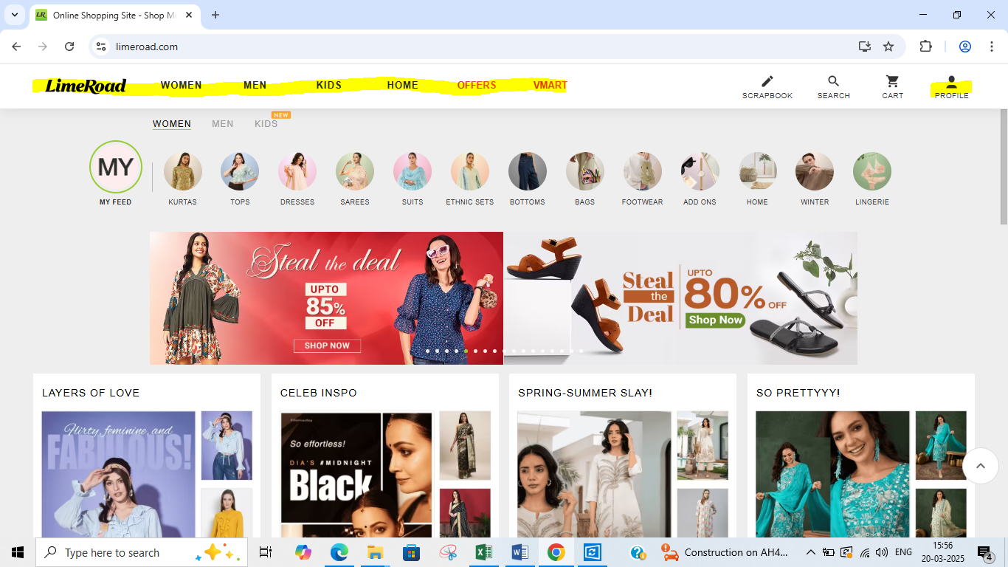

TC_017_Login & Logout

Validate the UI of login page

Launch he browser > Enter the URL and credentials > Click the login button

Login page UI is adhering to the UI checklist

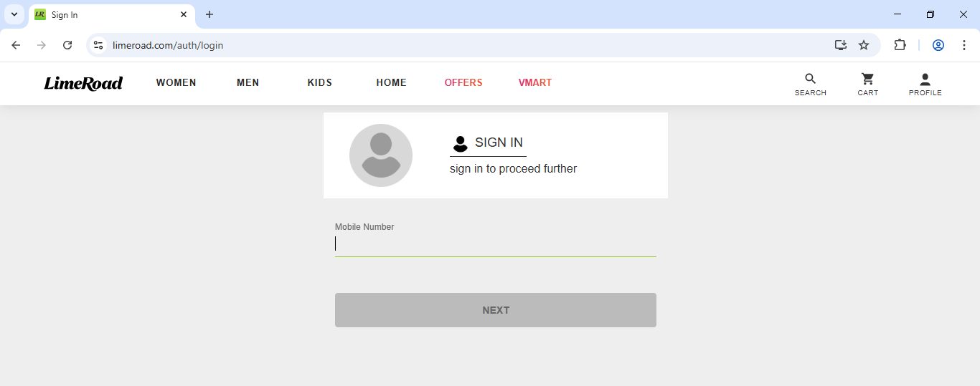

TC_018_Login & Logout

Validate the login page functionality in all the supported environments

Launch he browser > Enter the URL and credentials > Click the login button

Login functionality is working correctly in all the supported environments

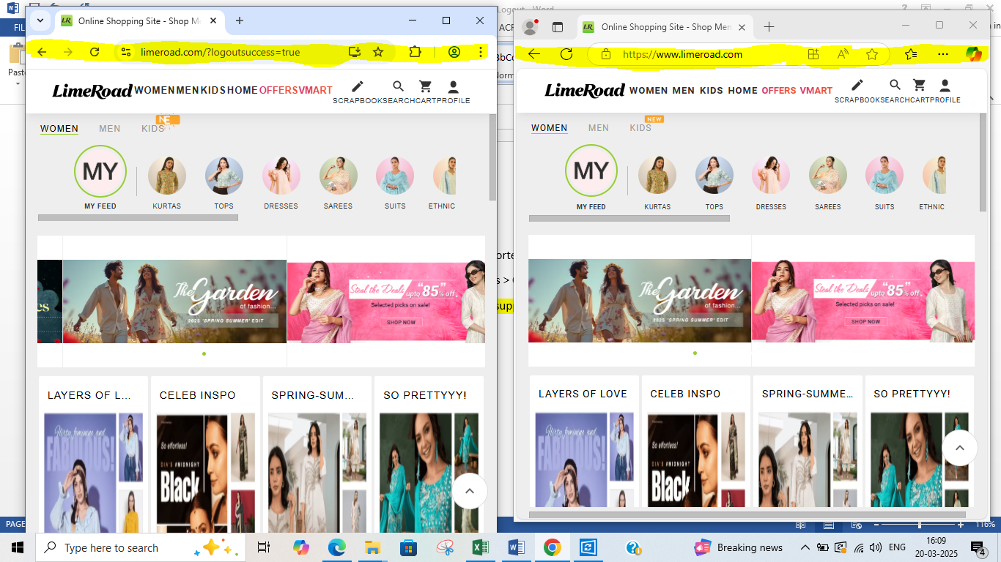

TC_019_Login & Logout

Validate after login , logout button is visible or not

Launch he browser > Enter the URL and credentials > Click the login button > Validate after login , logout button is visible or not > Click the next button OTP will receive to register phone number > Enter OTP and click verify button > Click on profile in home page

System displayed Logout button visible in profile



TC_020_Login & Logout

Validate by clicking on logout button without internet connection

Click on profile in home page > Dissconnect the internet from the device > Click on logout button

A pop message to show an error "No internet connection detected"

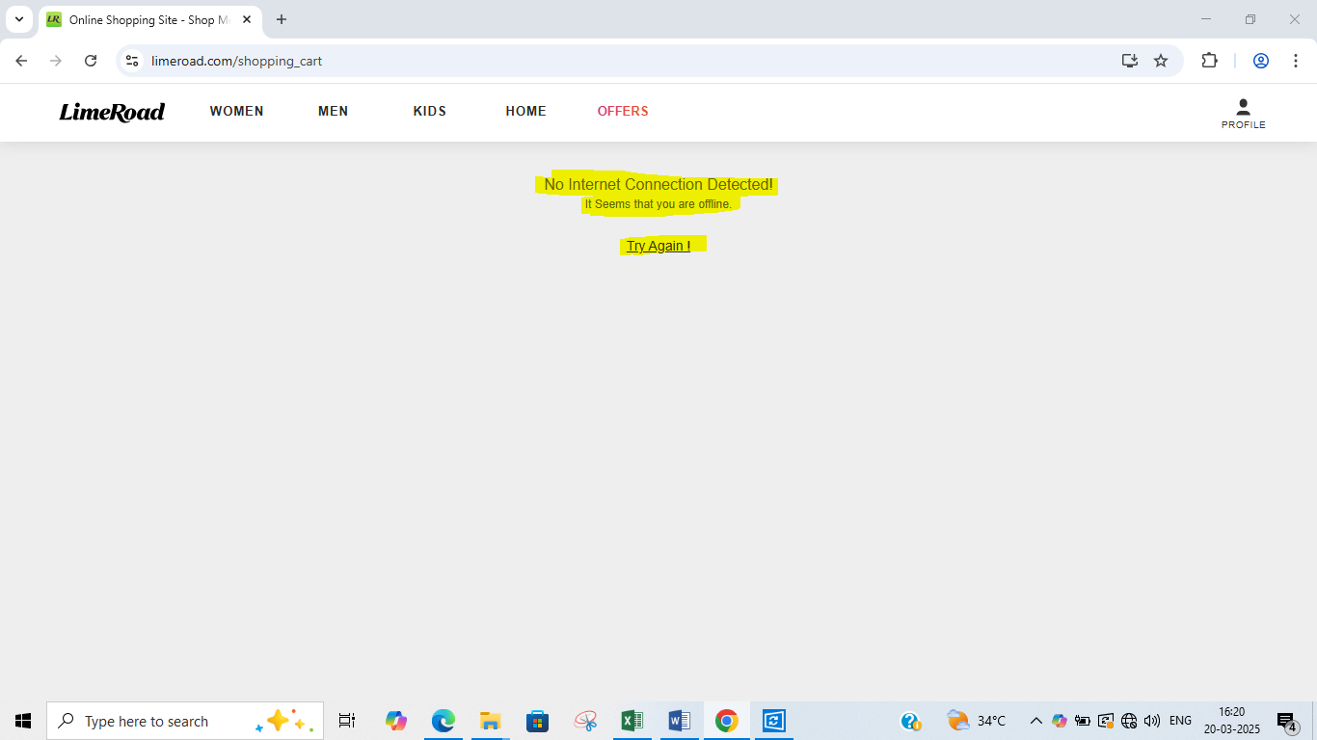

TC_021_Login & Logout

Validate by reconnecting the internet and check the application is logged out or not

Launch he browser > Enter the URL and credentials > Home page is visbile

Application not logged out from the device



TC_022_Login & Logout

Validate the application by login into more than two browser and logout from one browser check all other account is properly logged out

Click on profile in home page > Click on logout button from one browser > Close all the browsers > Launch he browser > Enter the URL and credentials

Application successfully logged out from all the browsers

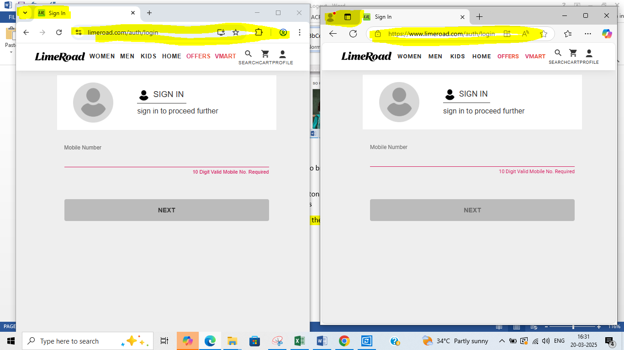

TC_023_Login & Logout

Validate the application by logging out

Click on profile in home page > Click on logout button

Application successfully logged out

